9.1.1 VOWELS IN A STRING
ALGORITHM
- Start
- Input string s
- Initialize count = 0
- For each character in string
- Check if character is vowel
- If yes, increment count
- Print count
- End
FLOWCHART
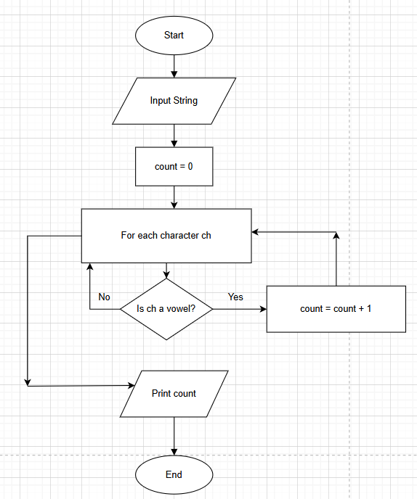

Python Code
inp = input()
count = 0
for ch in inp:
if ch in('A','E','I','O','U','a','e','i','o','u'):
count += 1

print(count)

Execution
